**DAILY ONLINE ACTIVITIES SUMMARY**

|  |  |  |  |  |  |  |  |
| --- | --- | --- | --- | --- | --- | --- | --- |
| **Date:** | | **1/6/2020** | | | | | |
| **Name of the Faculty** | | **REENA LOBO** | | | | | |
| **No. of Students Allotted for monitoring** | | | | | **19** | | |
| **Progress** | | | | | **GOOD** | | |
| **Whether collected report from all the allotted students** | | | | | **18,NOT SUBMITTED RAMITHA** | | |
| **Online Test Summary** | | | | | | | |
| **Subject** |  | | | | | | |
| **Semester** |  | | | **Duration** | |  | |
| **No. of students Taken** | | |  | **Passing %** | |  | |
| **Certification Course Summary** | | | | | | | |
| **Course** | | 1. Attended webinar on understanding analyticsCertification provider: SRITDURATION: 1 and half hour2.Completed module 2 of RPA COURSECERTIFICATION PROVIDER: ui pathDuration: 3hrs | | | | | |
| **Certificate Provider** | |  | | | **Duration** | |  |
| **Coding Challenges** | | | | | | | |
| **Define a class Point with two fields x and y each of type double. Also , define a method distance(Point p1, Point p2) to calculate the distance between points p1 and p2 and return the value in double. Complete the code segment given below. Use Math.sqrt( ) to calculate the square root.** | | | | | | | |
| **Status: COMPLETED** | | | | | | | |
| **Uploaded the report in Github** | | | | | **yes** | | |
| **If yes Repository name** | | | | | <https://github.com/reenalobo/ONLINE-ACTIVITY-REPORT/upload/master> | | |
| **Uploaded the report in slack** | | | | | **yes** | | |

Certification Course Details: (Attach the snapshot and briefly write the report for the same)

**Attended webinar on understanding analytics**

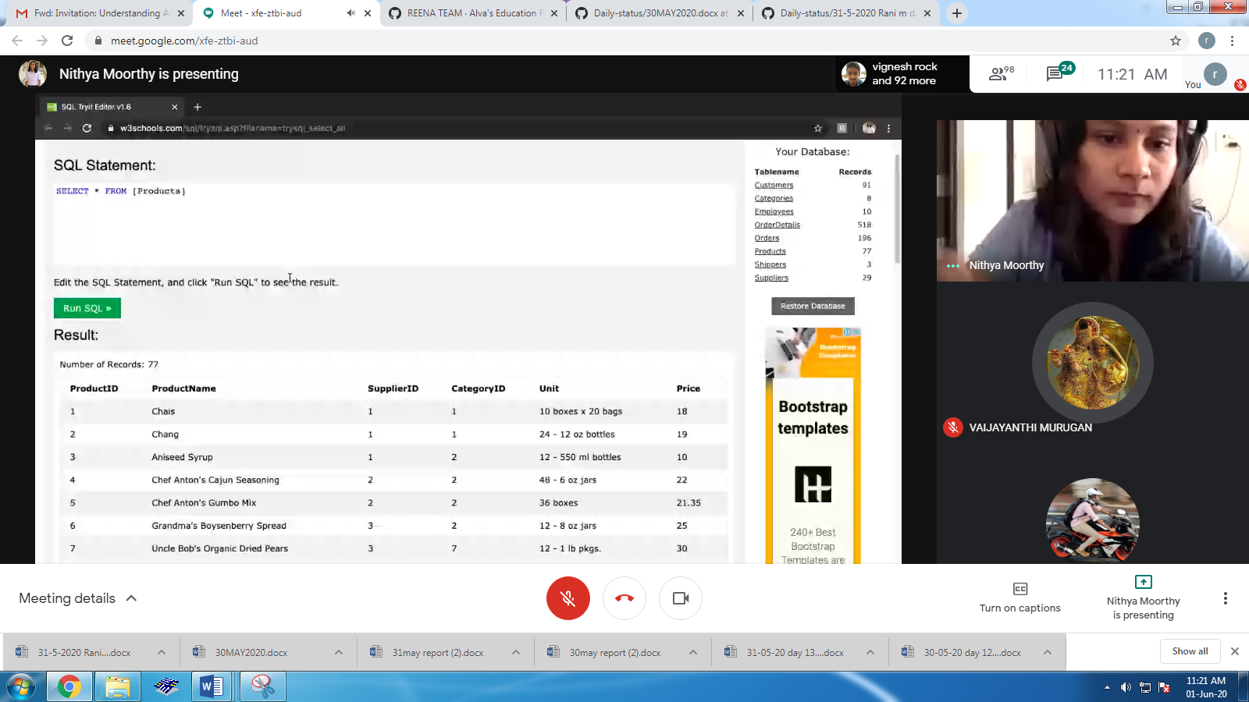

**Completed module 2 of RPA COURSE:**

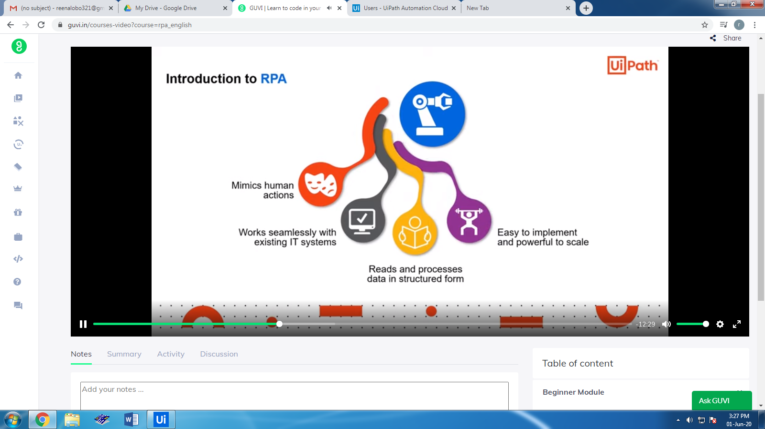

**CODING CHALLENGE:**

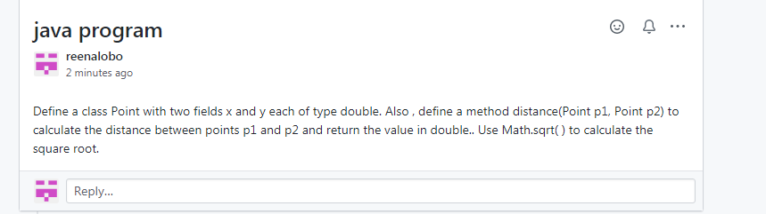

STUDENTS REPORT:

ROHAN MAHAVEER:

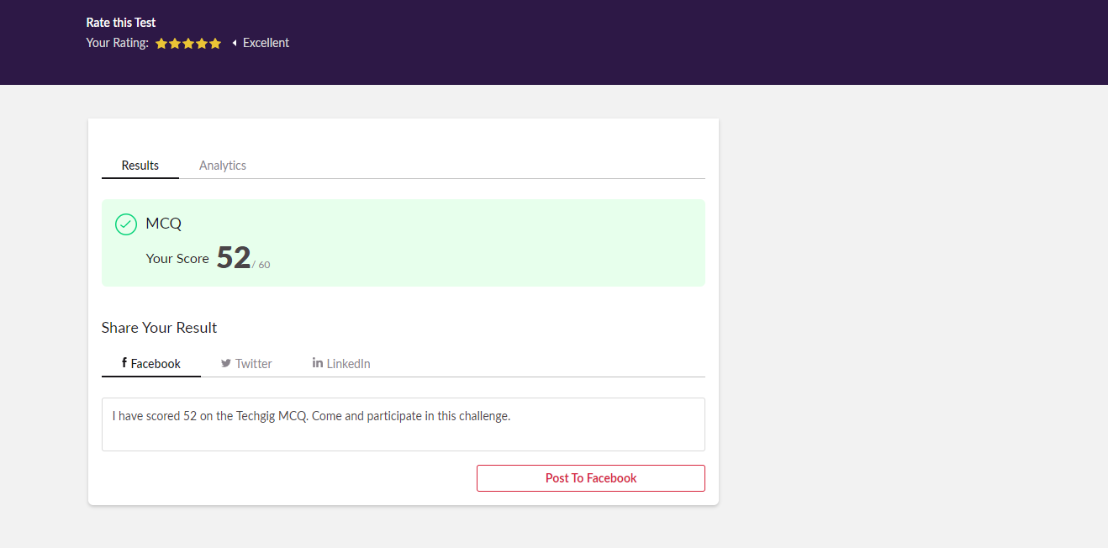

Scored 52 out of 60 in CNSC 2nd I.A test

Certification Course Details:

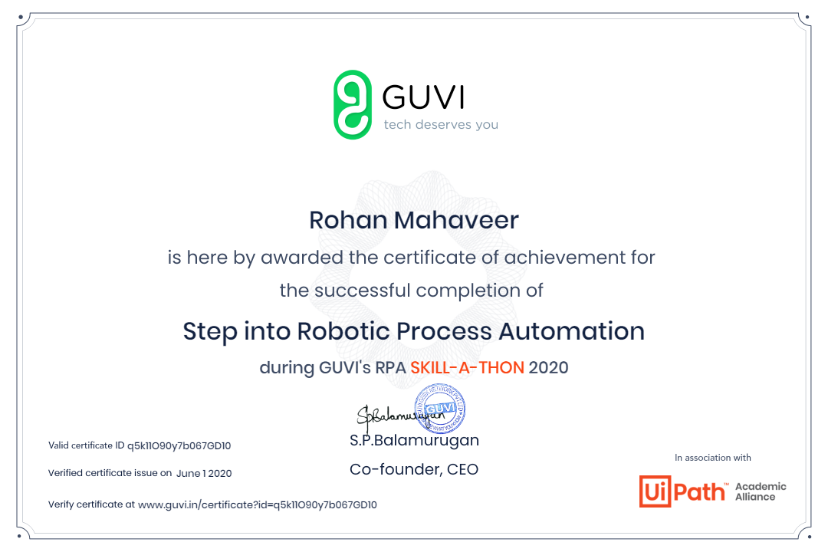

ATISH:

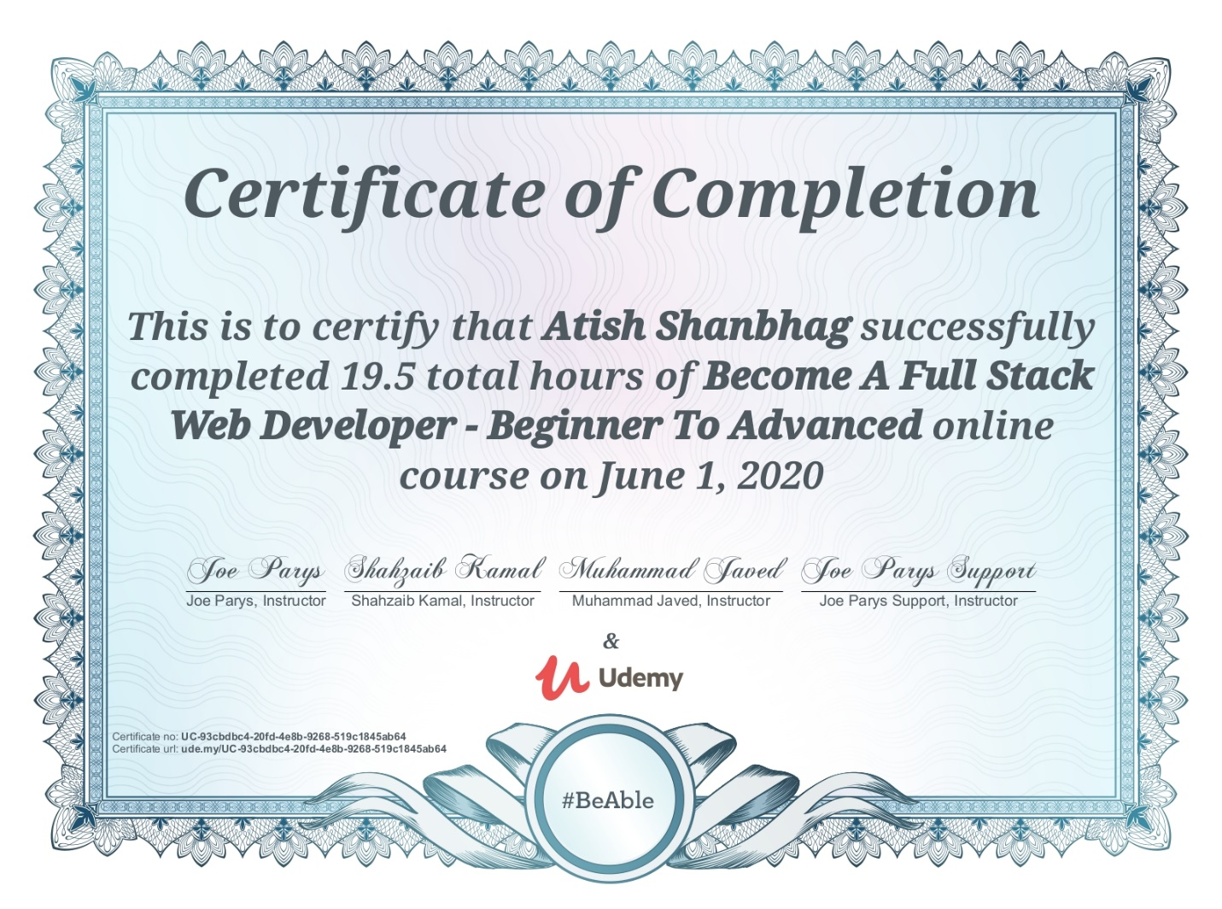

In today’s session for online certification successfully completed the course of Full stack web development course.

Coding Challenges Details:

The below GitHub link for details

<https://github.com/atish-shanbhag/Updates>

P-1

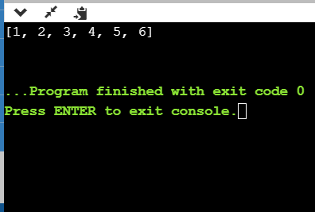

**Python program to remove duplicate values from list**

**P-2**

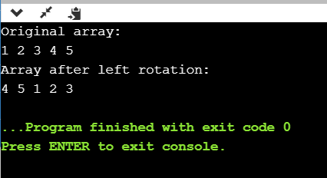

**Shah Dhruvil Amit:**

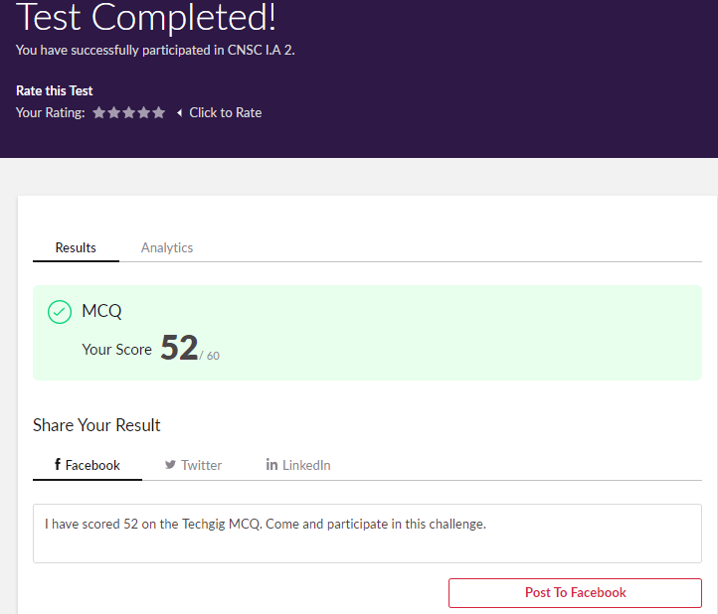

Certification Course Details:

Report



In today’s session for online certification course, I have created courses to be added to the cart and also getting data from the contentful database.

Coding Challenges Details:

The below GitHub link for details

<https://github.com/DhruvilShah99/Daily-Updates>

P-1



**Raksha S:**

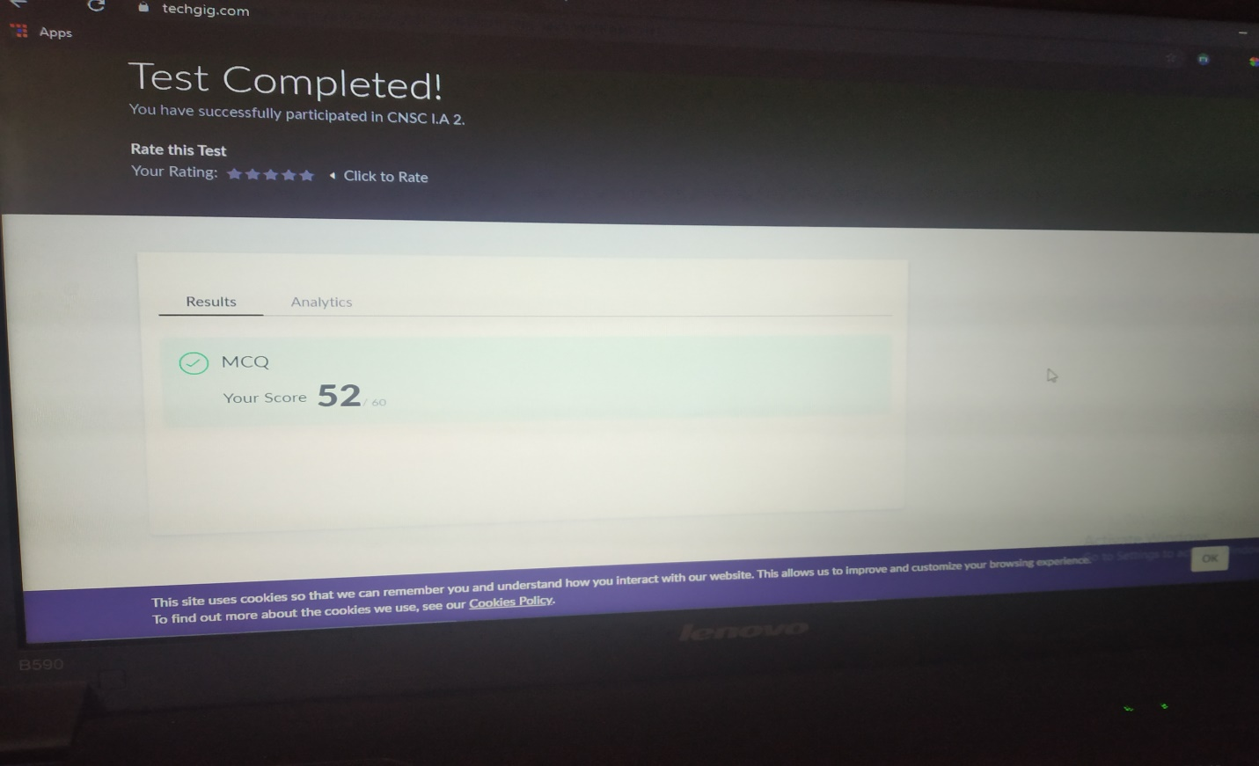

Scored 52 out of 60 in CNSC 2nd I.A test

Certification Course Details:

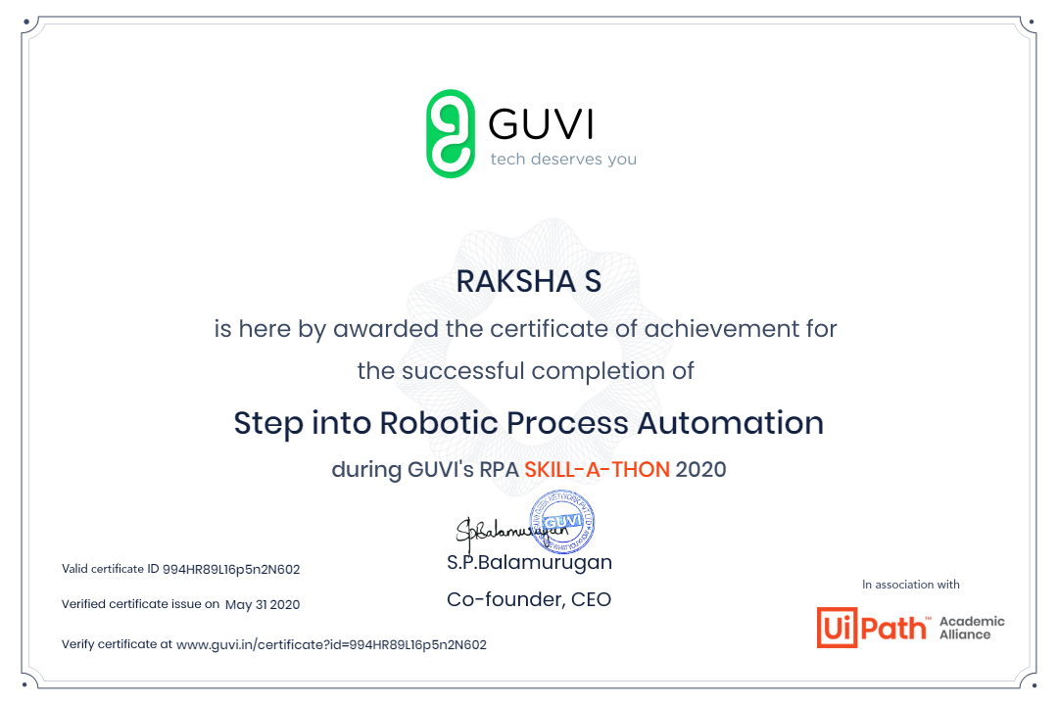

The above course is being taken up by me is based on Robotic Automation process. It started with the Introduction to RPA, Benefits of RPA, How to install the software and the first program was explained. The details of the course and certificate provider are mentioned in the above form.

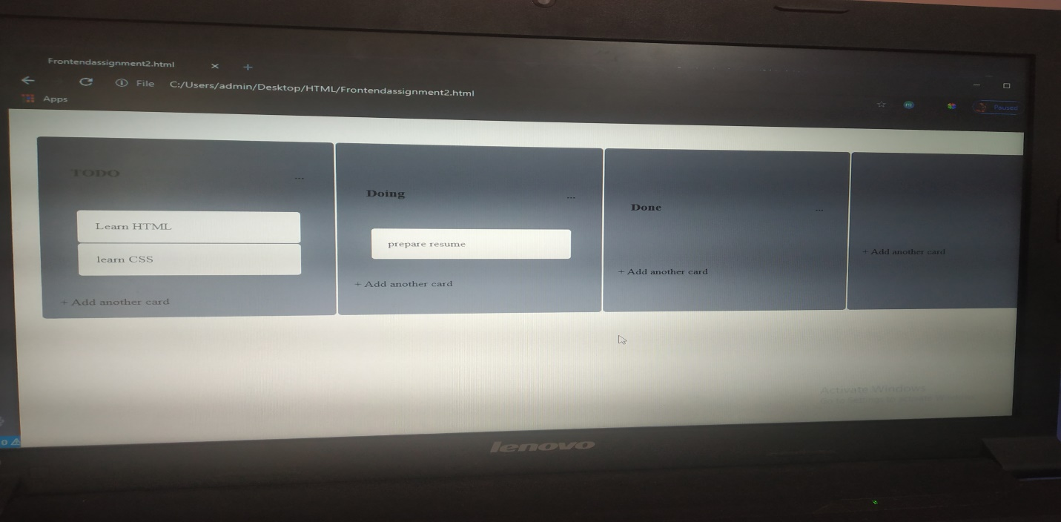

**Preethi:**

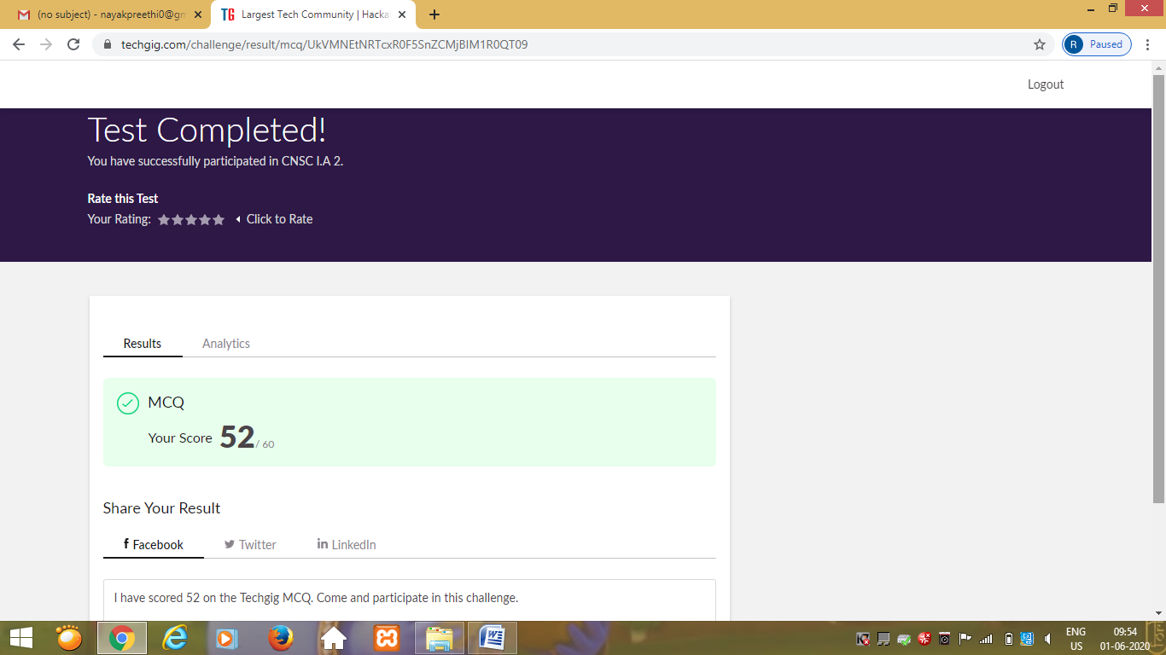

Certification Course Details: (Attach the snapshot and briefly write the report for the same)

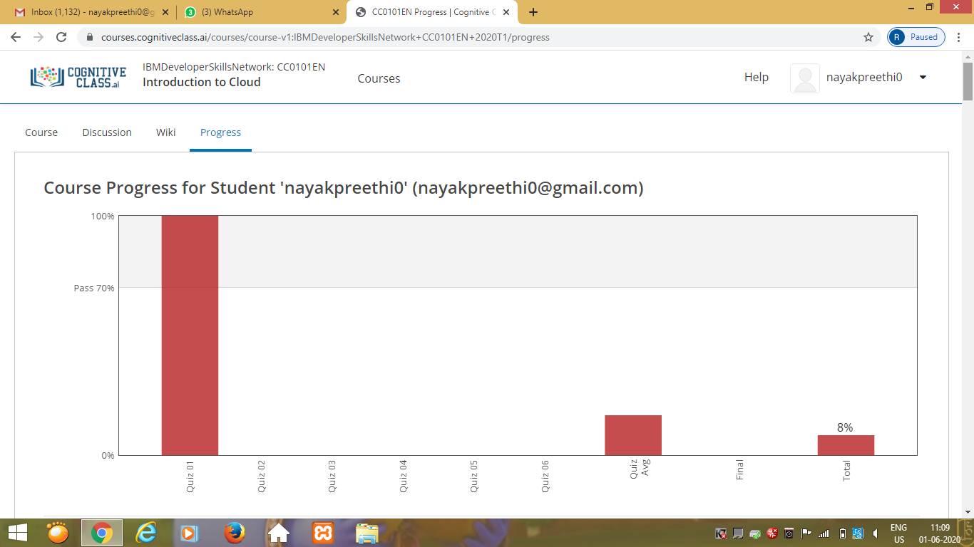

Rani:

RAGHAVI:

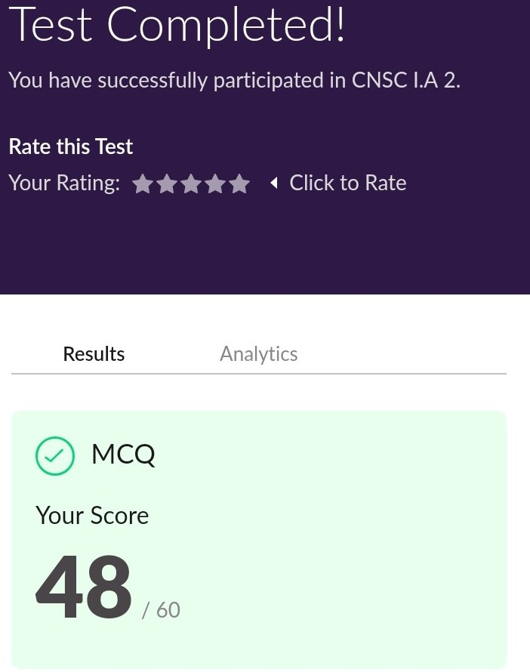

Certification Course Details:



**Pranav L M:**

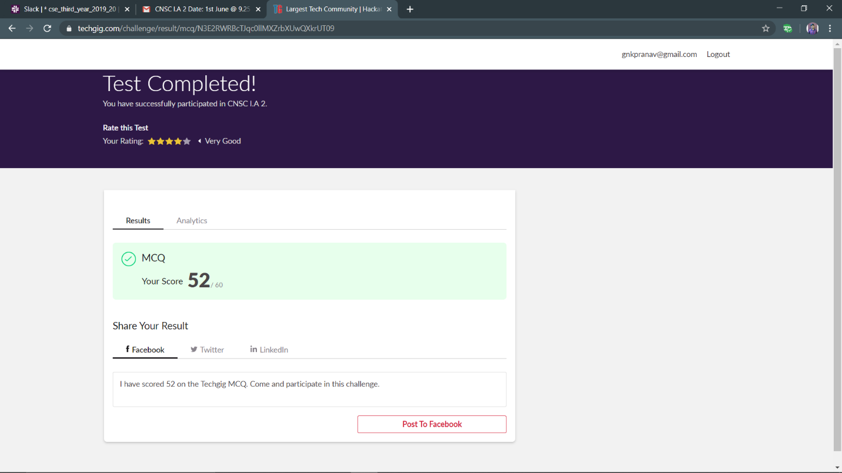

Certification Course Details

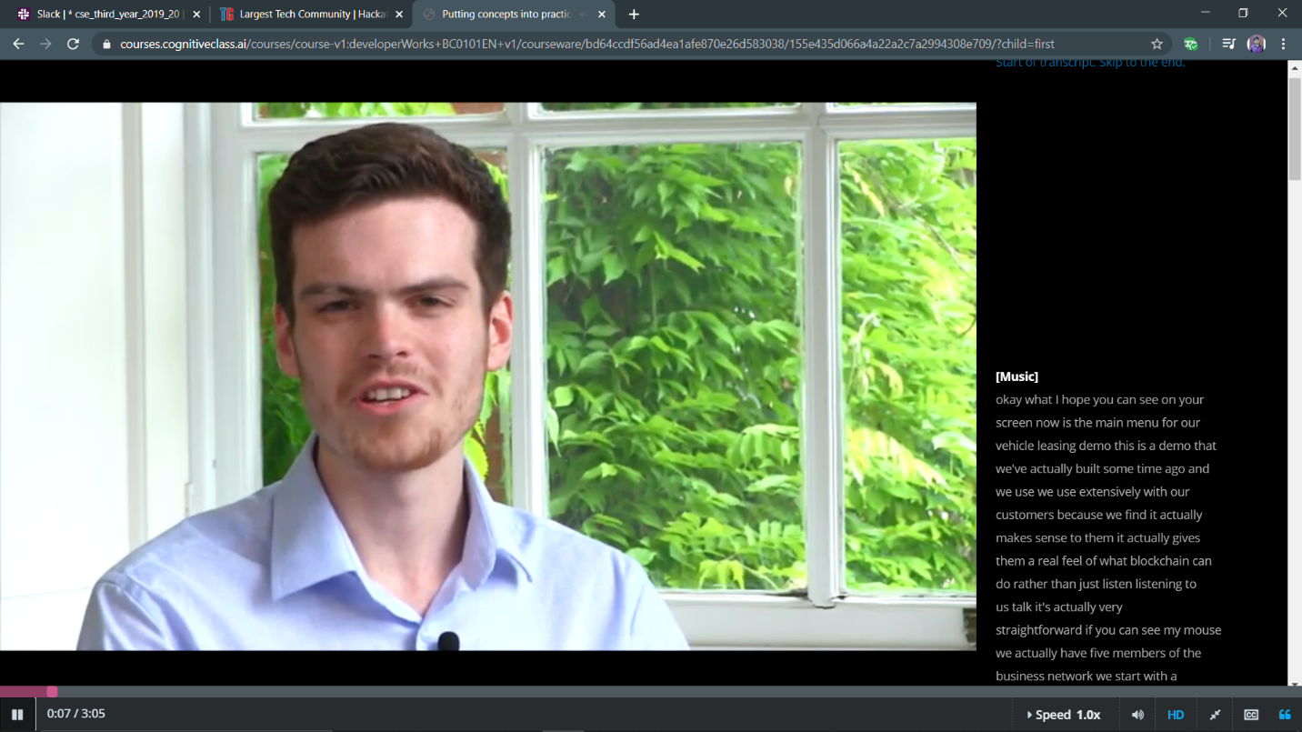

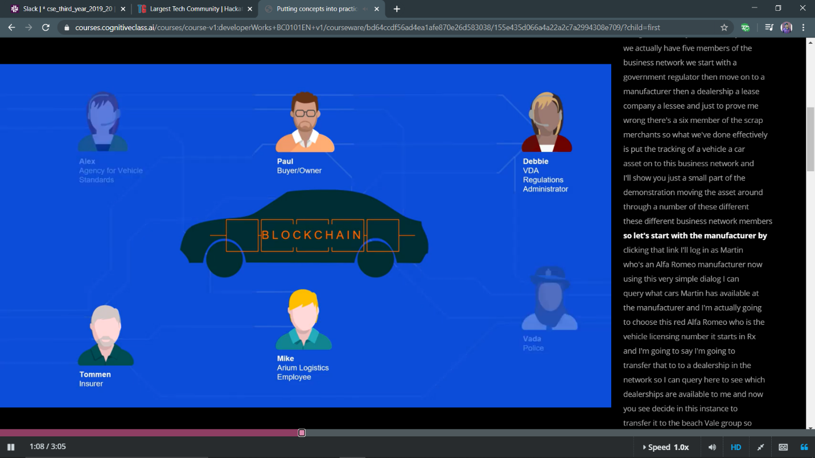

RAVALI:

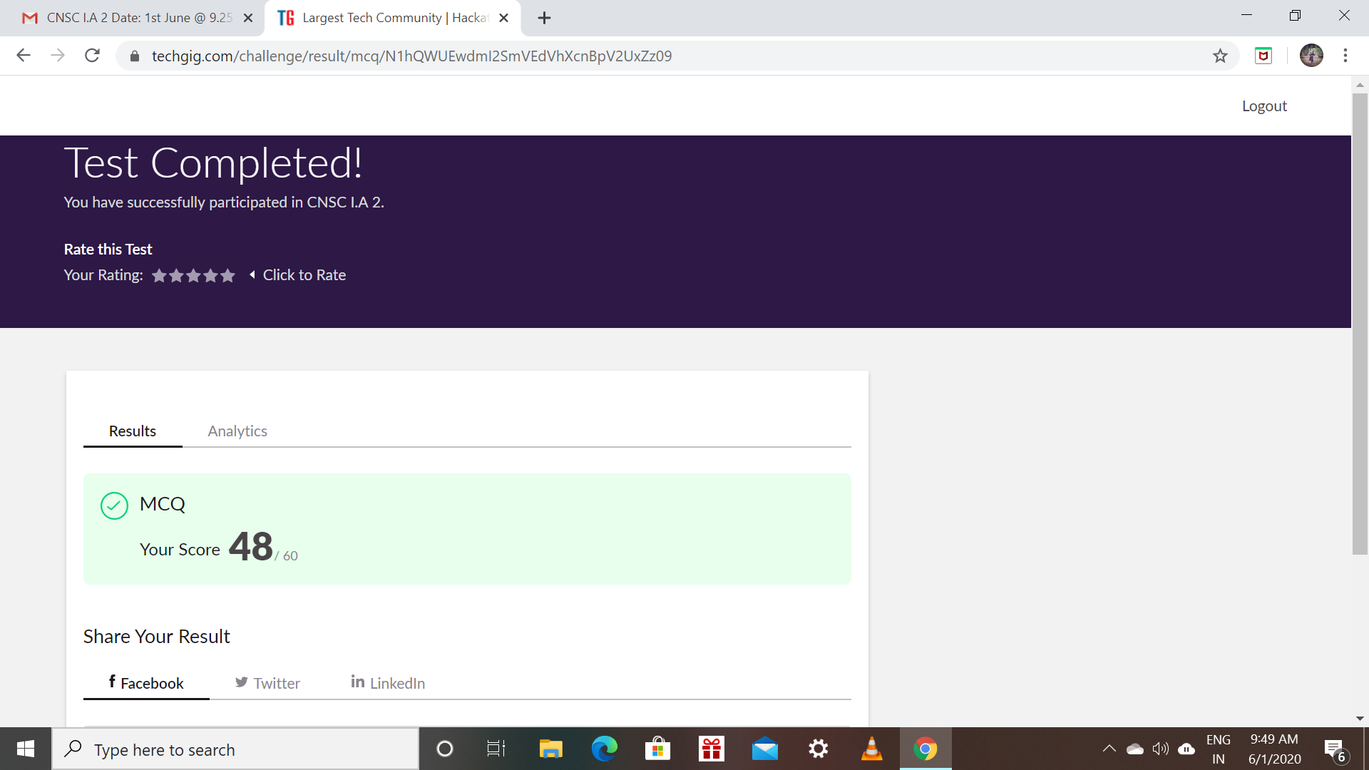

Certification Course Details: (Attach the snapshot and briefly write the report for the same)

* Todays topic about sample programs of python .
* How to clear the errors and knowing about indentation.
* At end of the module taken assignment.

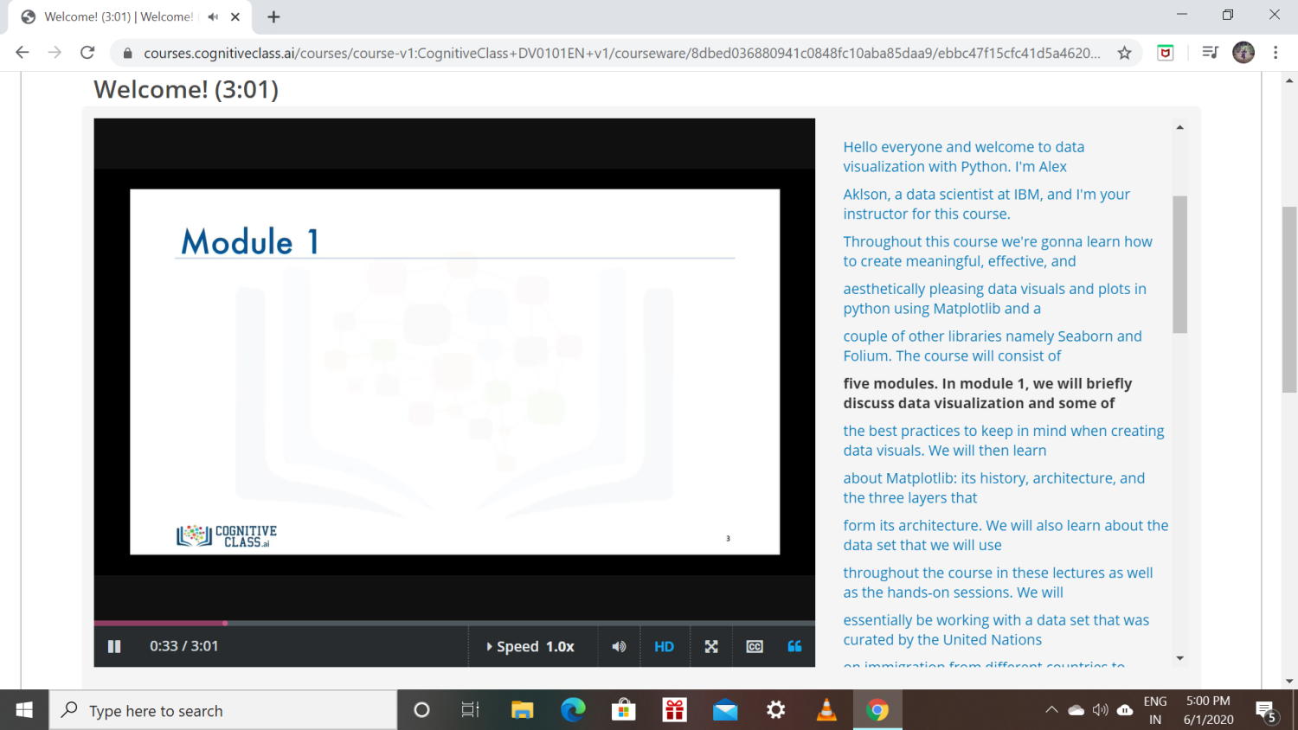

PRIYA:

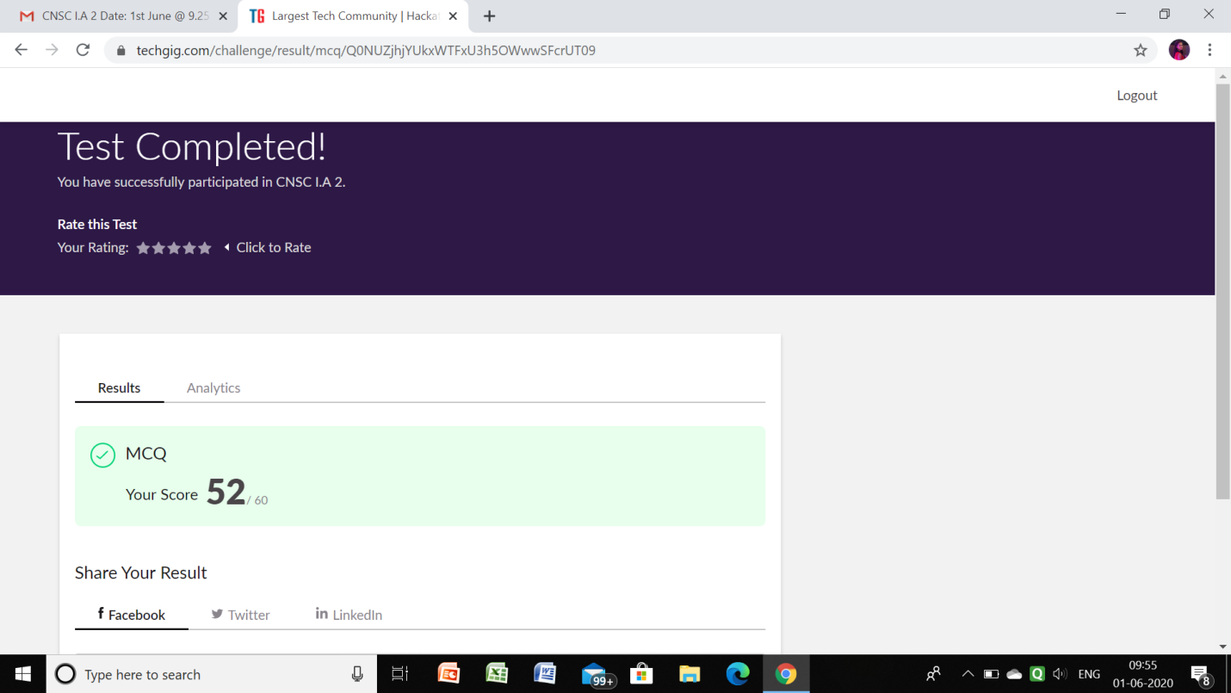

**Certification Course Details:**

Github link for information: <https://github.com/priya3028/Daily-status>

**Topics completed today:**

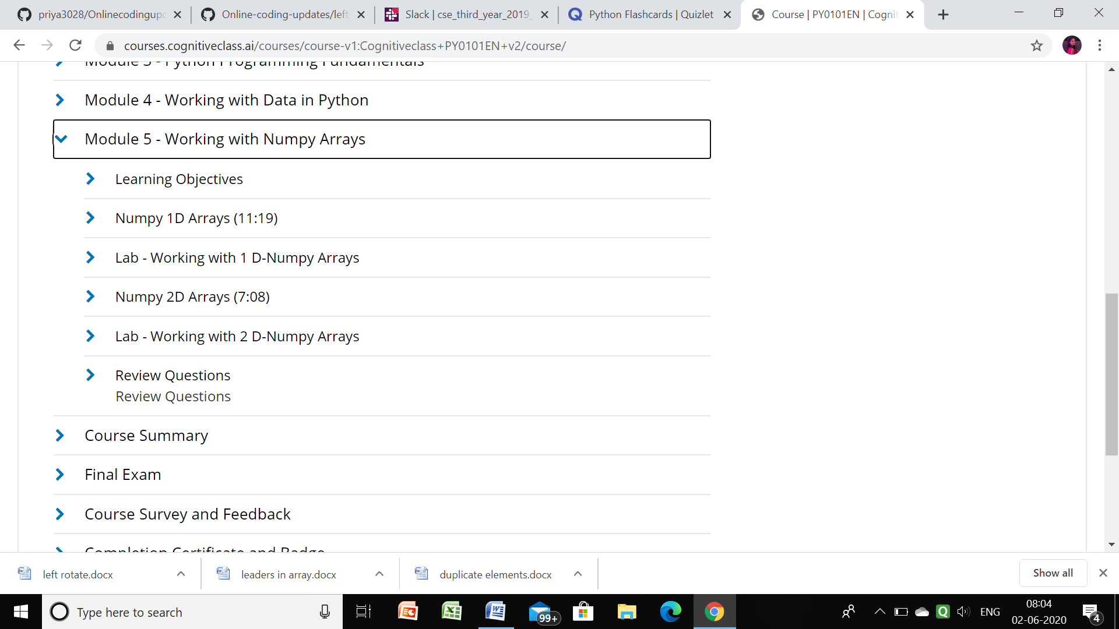

**Progress report:**

Priyanka:

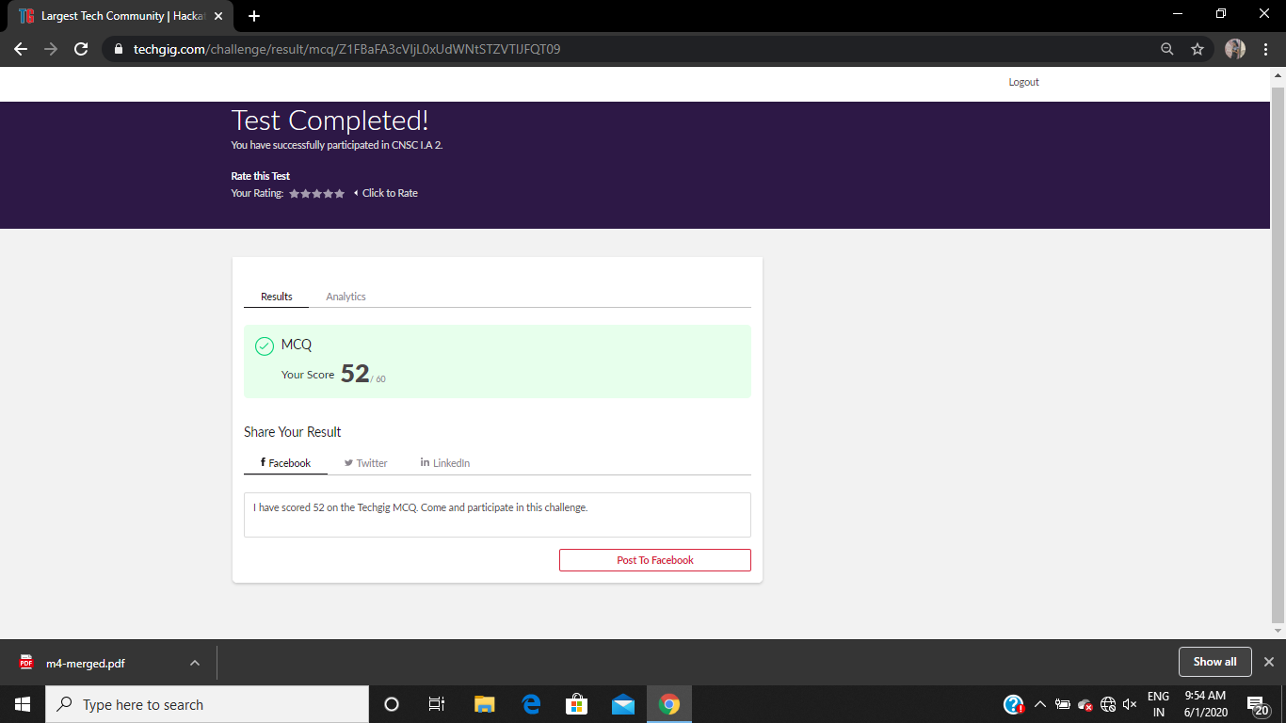

**Certification Course Details:**

**Today Progress:**

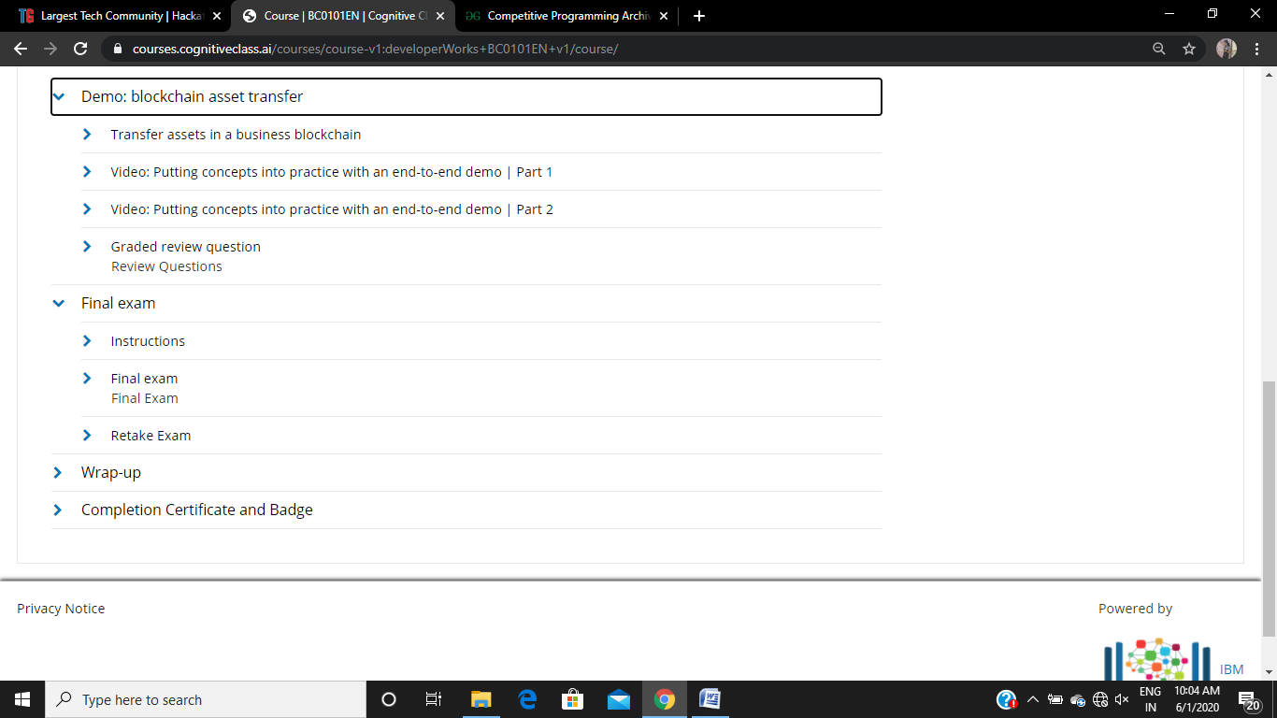

Completed the demo part.

**Coding Challenges Details:**

Refer the github link for detail information :<https://github.com/Priya-s-k/Online-coding-updates>

Solved all the problems and the solutions are uploaded in github account.

Rousha:

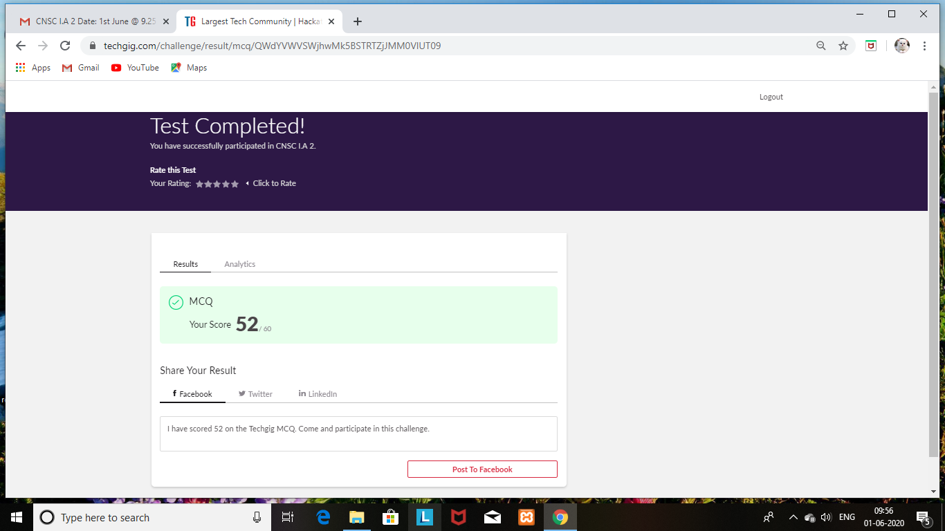

Certification Course Details: (Attach the snapshot and briefly write the report for the same)

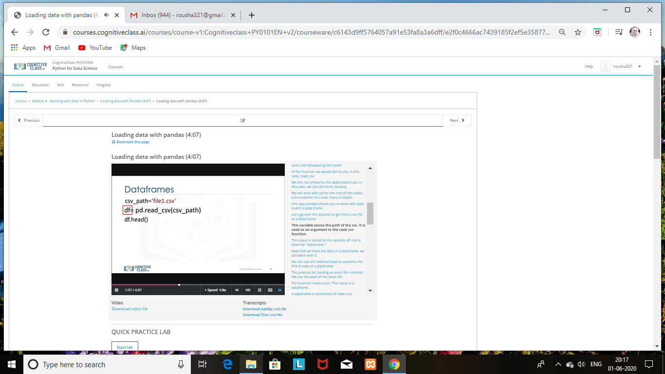

SHAIFA:

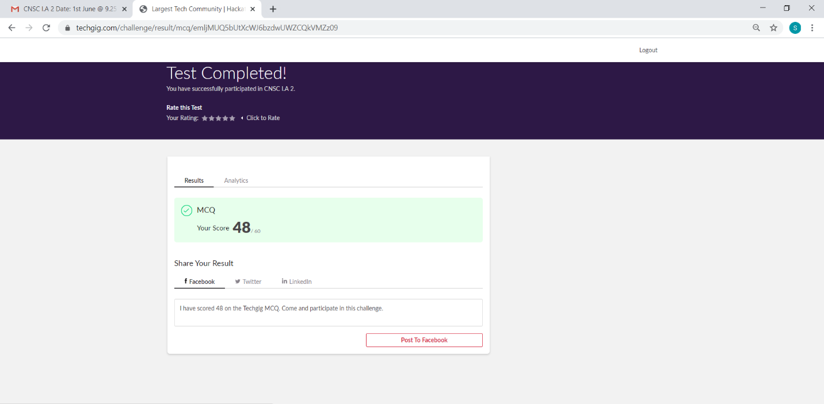

Certification Course Details: (Attach the snapshot and briefly write the report for the same)

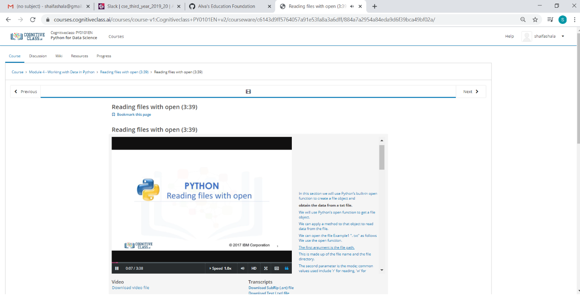

Rani:

Subject:-CRYPTOGRAPHY NETWORK SECURITY AND CYBER LAW

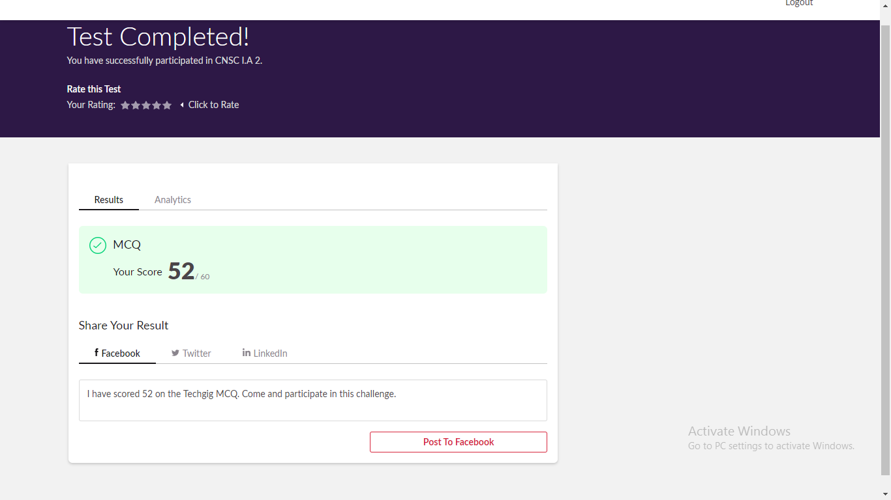

Certification Course Details:

1.

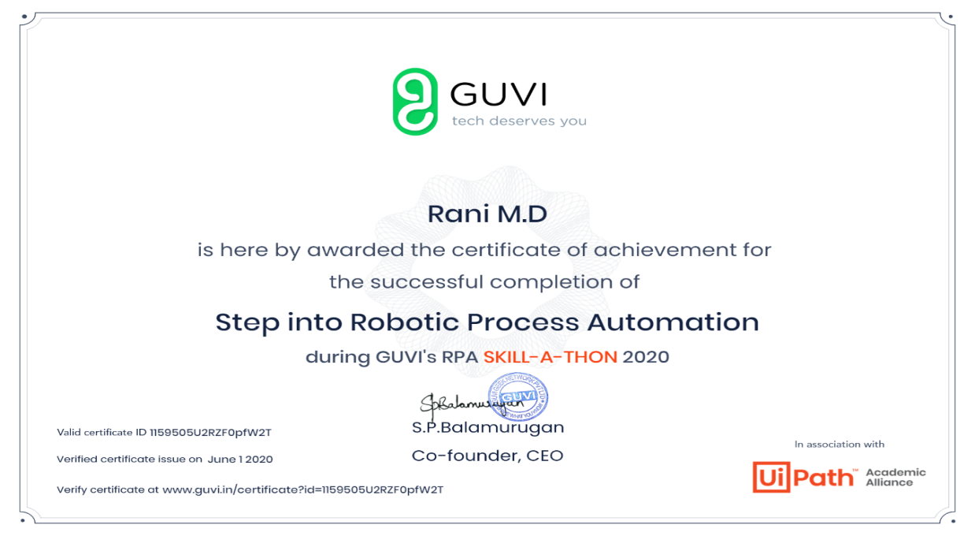

2.



Sana:

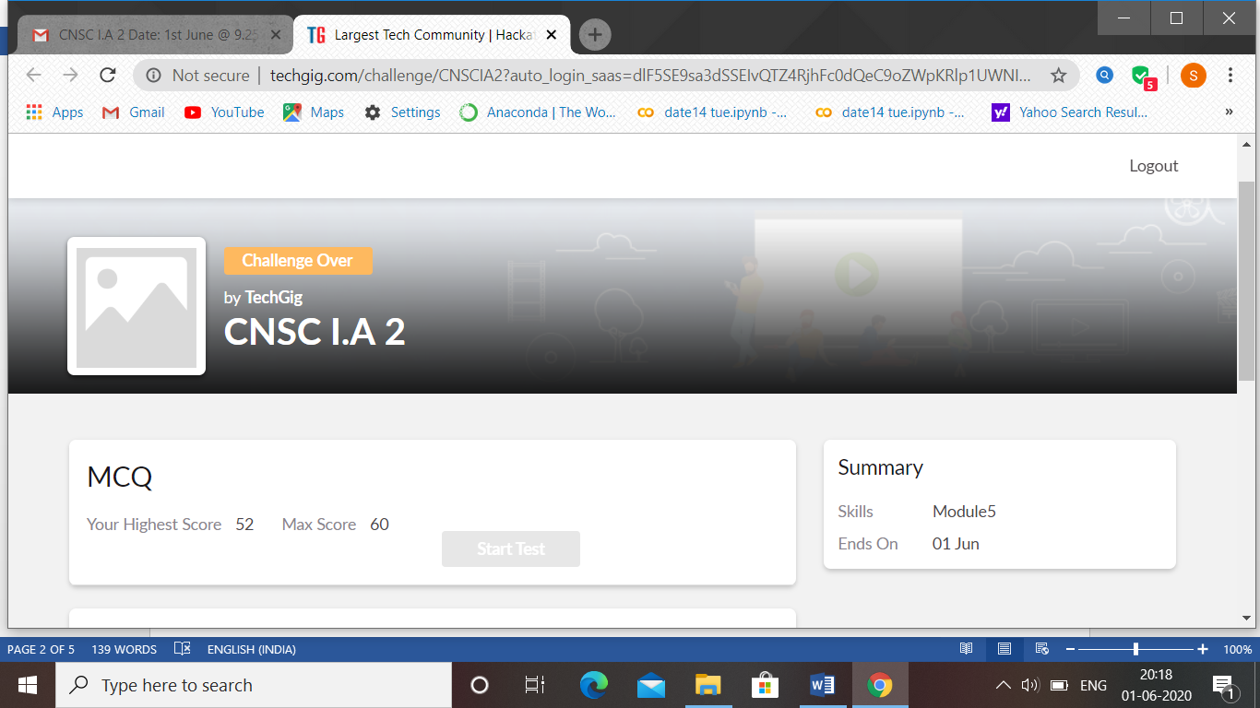

CNSC test 2 was held today i.e 1 June 2020. Out of 60 marks I scored 52.

Certification Course Details: (Attach the snapshot and briefly write the report for the same

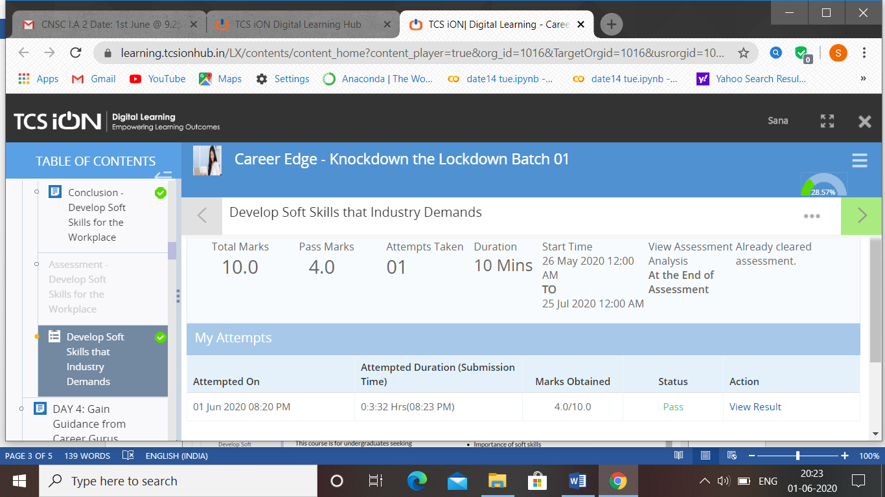

**RACHANA:**

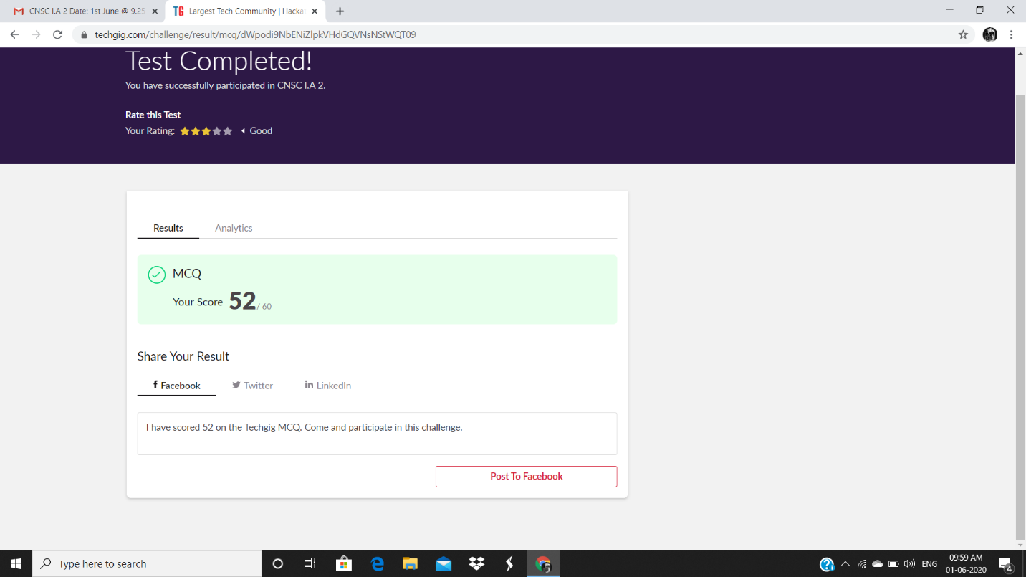

**Certification Course Details:**

**Today Progress:**

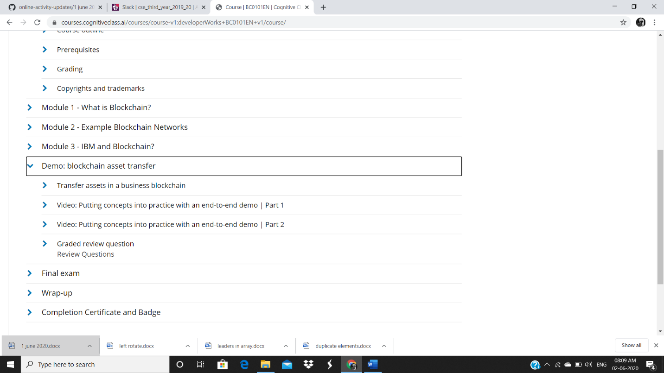

Completed the demo part.

ROHAN VASISTA:

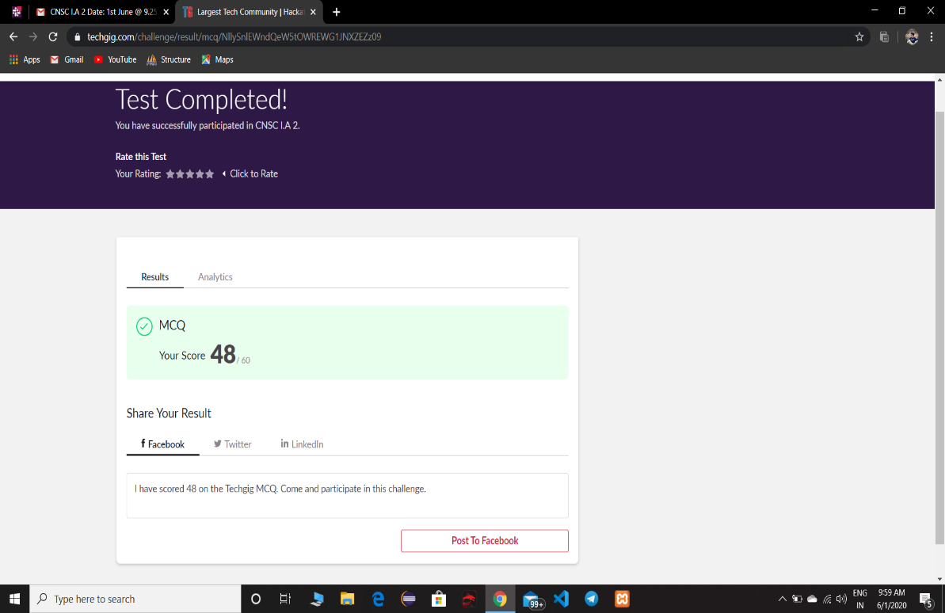

**Online Certification Details**

Completed modules

* Hacking methodology
* Scanning
* Gaining access an maintaining
* Covering topics

**CERTIFICATE OF COMPLETION**

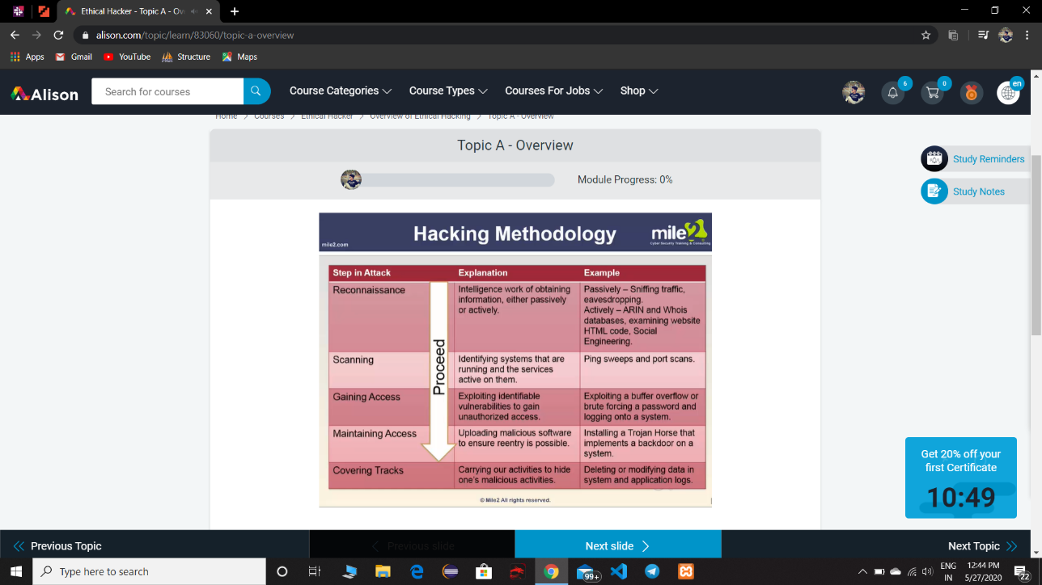

PRAVEEN KUMAR:

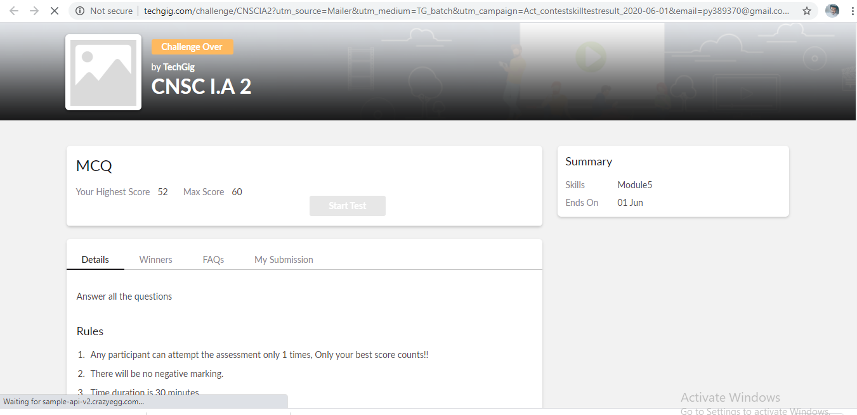

certification course snap

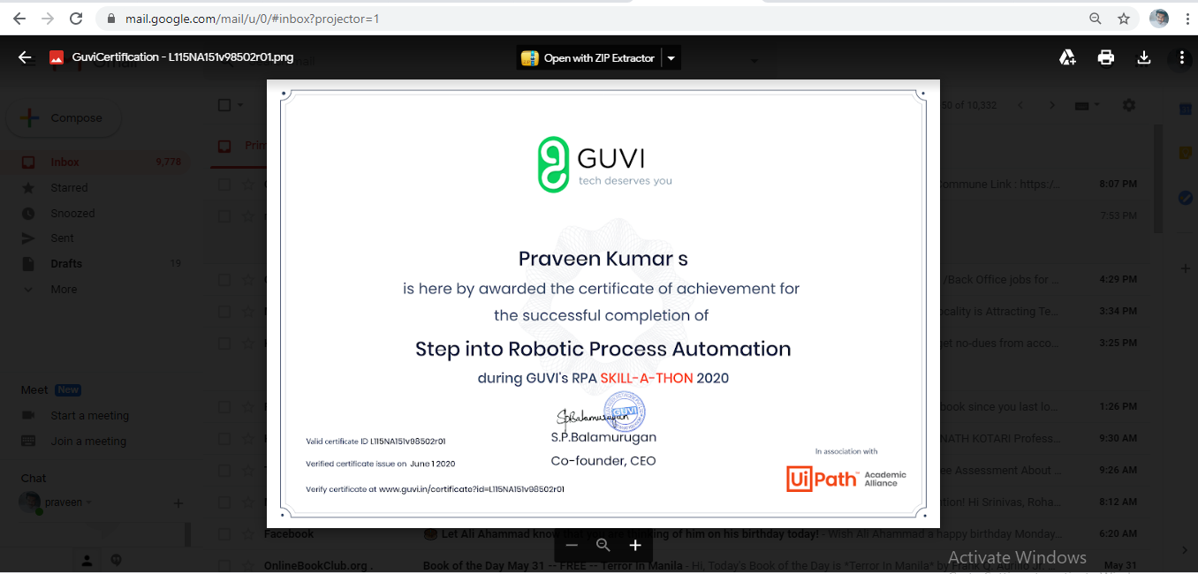

program snap

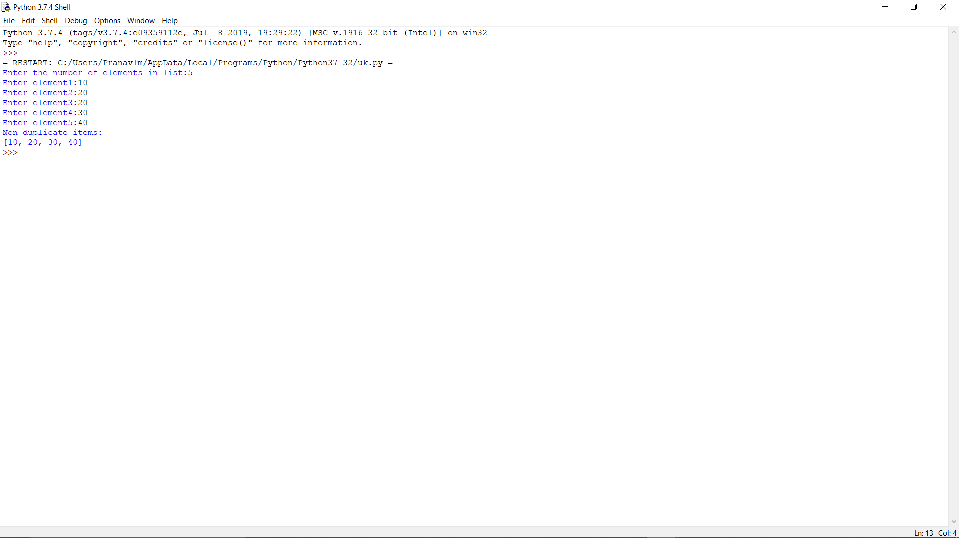

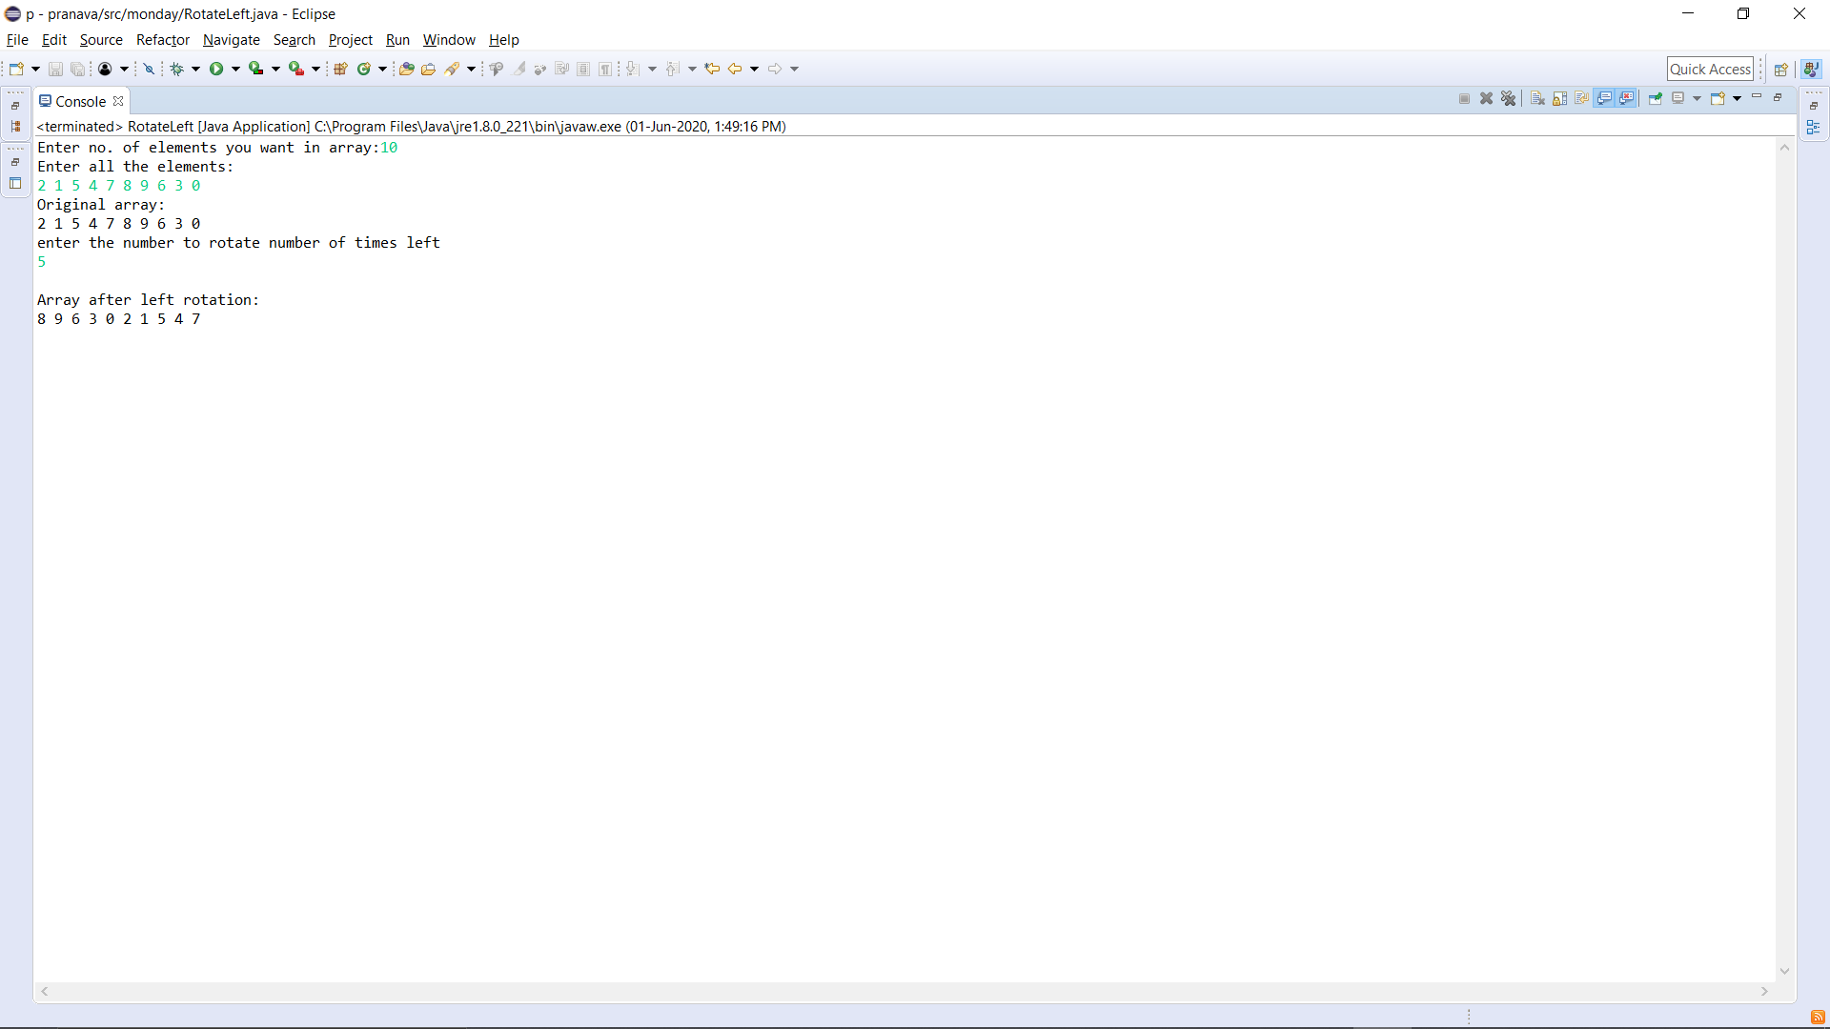

**SACHIN RAJORA:**

